
Diwali Festival Package –Srilanka
(01st November – 30th November 2026)

Itinerary 06 Nights & 07 Days
01N Kandy | 02Nuwara Eliya | 02N Bentota | 01N Colombo
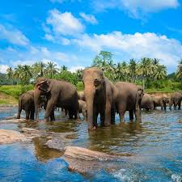
Day 01: Arrival / Kandy
Arrival at Colombo Airport
Transfer to the Kandy
En Route: Pinnawala Elephant Orphanage
En Route: Spice & Herbal Garden
Cultural Show & Gem Museum visit (Combine Complementary visit )
Dinner and Overnight stay at Kandy

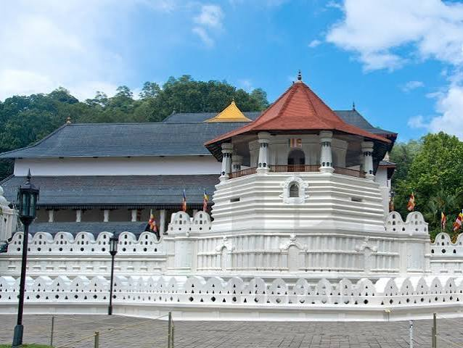
Day 02: Kandy / Nuwara Eliya
Breakfast at the hotel
Visit Temple of the Tooth
Kandy Lake & city sightseeing
Transfer to the Nuwara Eliya
En Route: Ramboda Hanuman Temple
Ramboda Falls
Tea factory and tea plantation visit
Dinner and Overnight stay at Nuwara Eliya

Day 03: Nuwara Eliya / Ella / Nuwara Eliya
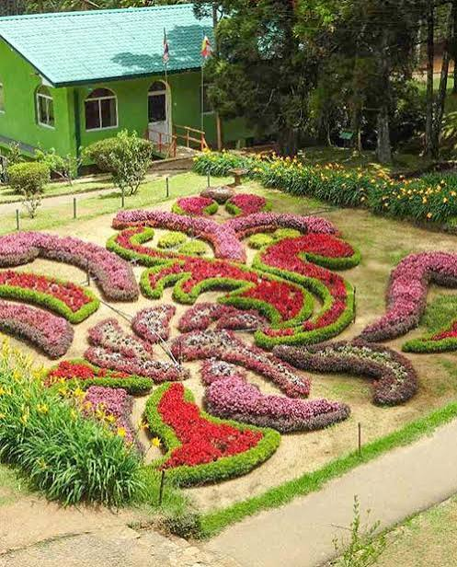
Breakfast at the hotel
Transfer to Ella for excursions
Ravana Falls
Visit nine arch bridge
Ravana Mega zipline, Ella swing & Ravana Pool club
Transfer back to Nuwara Eliya
En route visit Divurumpola Seetha Agni Pariksha Temple
Haggala Botanical Garden
Sitha Amman Temple
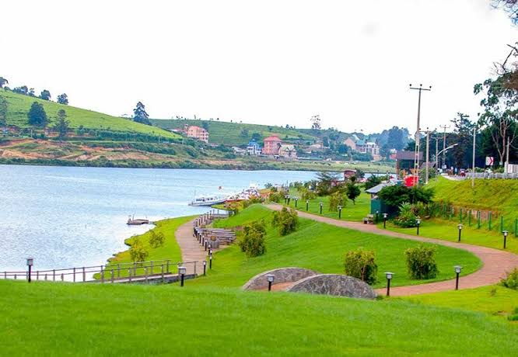
Dinner and Overnight stay at Nuwara Eliya

Day 04: Nuwara Eliya/ Bentota
Breakfast at the hotel
Enjoy Nuwara Eliya city & Gregory Lake, Victoria
Visit Gayathri Peetam
Transfer to the Bentota
Optional White-water rafting at Kitulgala
Dinner and Overnight stay at Bentota
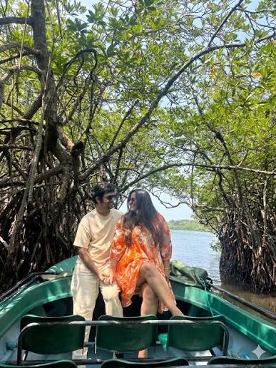
Day 05 : Bentota
Breakfast at Hotel
Madhu River Boat Safari
Turtle Hatchery
Water Sports at Bentota
Dinner and Overnight stay at Bentota

Day 06: Bentota / Colombo
Breakfast at the hotel
Transfer to the Colombo
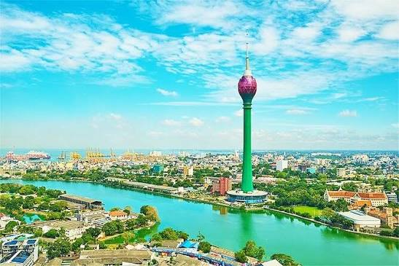
Visit Kelaniya Vibheeshana Temple
Anjaneer Temple visit
Optional Colombo night life (pub, casino…) (one way transfer only)
Dinner and Overnight stay at Colombo

Day 07: Colombo / Airport
Breakfast at the hotel
Colombo City Tour & Shopping
Transfer to the Airport
Fly Back with Sweet memories from Sri Lanka

Option A – 3*
Hotels are subject to availability. Rates & Taxes are subject to change as per government regulations.
No of Nights | Destination | Hotels
01N | Kandy | Ganga Addara Hotel – Deluxe Room – 3*
02N | Nuwara Eliya | Single TreeMount Hotel - Deluxe Room – 3*
02N | Bentota | Hibiscus Beach Hotel – Deluxe Room – 3*
01N | Colombo | Berjaya Colombo – Deluxe Room – 3*

Option A – 4*
Hotels are subject to availability. Rates & Taxes are subject to change as per government regulations.
No of Nights | Destination | Hotels
01N | Kandy | Royal Kandyan – Deluxe Room – 4*
02N | Nuwara Eliya | Araliya Red - Deluxe Room – 4*
02N | Bentota | Earl’s Regent Beruwala – Deluxe Room – 4*
01N | Colombo | Mirage Colombo – Deluxe Room – 4*

Option B – 5*
No of Nights | Destination | Hotels
01N | Kandy | Grand Kandyan Hotel – Deluxe Room – 5*
02N | Nuwara Eliya | Araliya Green City – Superior Room – 5*
02N | Bentota | Cinnamon Bey Beruwala -Superior Room – 5*
01N | Colombo | NH Collection Colombo – Superior Room – 5*

Rates (per person in US$)
All rates in USD per Person on Half-Board Basis
Pax count | Rooming Basis | Vehicle | Rate PP with  3 Star Option US$ | Rate PP with  4 Star Option US$ | Rate PP with  5 Star Option  US$
2 Pax | DBL | Sedan | 425 | 505 | 640
4 Pax | DBL | F/R Van | 360 | 440 | 580
6 Pax | DBL | High Roof Van | 335 | 415 | 555
6 Pax | TPL | High Roof Van | 315 | 375 | 495
Child Rates (Below 11.99 Years) | CWB  (5-11.9 Yrs) |  | 165 | 200 | 270
Child Rates (Below 11.99 Years) | CNB  (5-11.9 Yrs) |  | 90 | 115 | 185
Child Rates (Below 11.99 Years) | Below  4.99 Yrs) |  | FOC | FOC | FOC
Train Ticket Supplement per person including Children above 2.99 Years – US$ 20.00 pp for Guaranteed Train Tickets on Open Window compartment for Best Experience

ABOVE PACKAGES INCLUDE
- Arrival assistance at the Colombo Airport by our representative.
- Garland Welcome at the Airport
- Accommodation in the hotels mentioned or similar. Check-in 14h00 / Check-out 12h00 noon
- Stay at according to above mentioned Stay Basis.
- Meals on Breakfast & Dinner basis at all Hotels
- One 500ml water bottles per person per day while on tour
- 01 Local SIM card per room with 1GB data
- All transfer by Air-conditioned private vehicle with an English-Speaking National Guide
- All sightseeing According to the given itinerary without entrance fees
- Fuel and Local insurance for the vehicle.
- All Parking, highway tolls and chauffeur expenses for tour.
- 15% Exclusive Discount Voucher at Spice & Herbal Garden.
- 15% Exclusive Discount Voucher at Amith Gems Kandy.
- Complementary visit spice & Herbal garden
- Complementary visit Tea plantation & Tea factory
- Kandy cultural show & Gem Museum combine & complementary visit
- All applicable tax in Sri Lanka

ABOVE PACKAGES EXCLUDE
- Visa Fees (Apply ETA https://eta.gov.lk/slvisa/ )
- Video and Camera permits at sights.
- Meals Outside of the stated meal plan.
- Use of vehicle other than the specified itinerary.
- Expenses of personal nature.
- Any other services not specified above.
- Early check in & Late check out at the hotels (Check in & Check out time 12.00 to 12.00 Noon)

CANCELLATION CLAUSE
Cancellation ups to 30 Days No cancellation fee
Cancellation 29 -14 days 50% of the total cost
Cancellation less than 14 days 100%

